  MASTER OF MANAGEMENT ANALYTICS  PREPARED BY  Team Agnes  Mutasha Lin  INSTRUCTOR  Alex Scott  COURSE  MMA 860  DATE  August 8, 2026 | FINAL PROJECT  Rossmann Store  Sales Forecast  A predictive analytics study forecasting two months of daily sales across Rossmann's network of 100 European drugstores, using historical transactions, promotional, and store attribute data to support inventory and staffing decisions.

Table of Contents

Table of Contents 1
I. Executive Summary 2
II. Data Source 3
2.1 Dataset Scope 3
2.2 Variables and Business Definitions 3
2.3 Data Quality and Feature Engineering 4
2.4 Analytical Design and Limitations 4
III. Business Techniques 5
3.1 Data Cleaning and Quality Assessment 5
3.2 Data Integration and Feature Engineering 6
3.3 Data Exploration and Visualization 7
3.3.1 How Daily Sales Vary Across Key Business Conditions 7
3.3.2 How the Business Predictors Relate to Regular Daily Promotion 8
3.3.3 Promo2 Participation and Sales 9
3.4 Predictive Modelling with OLS Regression 10
3.5 Model Assessment and Hypothesis Testing 11
3.5.1 Heteroskedasticity assessment 11
3.5.2 Residual normality 12
3.5.3 Outlier and Influential observations 12
3.5.4 Business Hypothesis Testing 13
3.6 Prediction Performance 17
3.6.1 Point Prediction Accuracy 17
3.6.2 Prediction Intervals 18
IV. Conclusion and Model Limitations 19
V. Technical Appendix 20
Appendix A. Model Specifications 20
Appendix B. Candidate-Model Comparison 22
Appendix C. Hypotheses and Wald-Test Results 25
Appendix D. Residual Diagnostics and HC3 Robust Inference 26
Appendix E. Outliers, Leverage, and Cook's Distance 28
Appendix F. Prediction Validation and CI/PI 30
Appendix J. Notebook and Code Reference 32

Executive Summary
This project evaluated whether Rossmann could use information known before the sales day to improve daily store-sales forecasts and support promotion, inventory, and staffing decisions. The analysis used complete daily records for 100 stores from January 2014 through February 2015, with 2014 used for model development and January–February 2015 retained as an unseen test period.
The selected All Business Interactions model performed best among all candidate models. It achieved the highest explanatory power (training $R^{2}$of 0.8323 and test $R^{2}$of 0.8293 on LogSales) and the lowest prediction errors on the test data (Test RMSE and MAE were 0.1851 and 0.1331), while its training and test results were very similar. This indicates stable performance on unseen data, with no material evidence of overfitting, and supports its use as a reliable basis for day-to-day operational planning.
The largest forecast improvement came from allowing each store to have its own baseline sales level. This means that persistent differences among stores—such as location, customer mix, local traffic, operating capacity, product availability, and management quality—explain a substantial share of daily sales variation. Rossmann should therefore use store-specific forecasts rather than one common forecast across the network.
Regular promotions remain an important sales driver after controlling other factors, but their effectiveness is not uniform. Promotion response varies by weekday, StoreType, Assortment, school-holiday status, and Promo2 plan. Under the model’s Monday reference conditions, the estimated promotion uplift is 78.7%, declining to 37.4% by Friday. Management should therefore avoid applying one chain-wide promotion assumption and instead tailor promotional inventory and staffing to the relevant store-day conditions.
Promo2 requires careful interpretation. In the raw descriptive data, average Sales during active Promo2 periods were approximately 2.8% lower than during inactive periods. However, after controlling store differences, seasonality, regular promotions, holidays, and other predictors, Promo2 and its interaction with regular promotion were jointly significant. This means Promo2 provides useful forecasting information and changes how stores respond to regular promotions, but it should not be interpreted as automatically increasing Sales.
Competition distance showed visible differences in the descriptive analysis, but competition exposure and its interactions were not statistically significant after controlling for store-specific differences and other operating conditions. This does not mean competition is unimportant. Rather, distance alone is an incomplete measure because it does not capture competitor size, pricing, quality, customer traffic, or local market density.
Prediction intervals further demonstrated the model’s practical value. The 95% prediction intervals captured 95.30% of actual test-period Sales observations, closely matching the intended coverage level. The 99% prediction intervals captured 97.74%, indicating that uncertainty may still be understated for a small number of unusually high- or low-sales days. Management should therefore use point forecasts as central estimates and prediction intervals as realistic planning ranges for inventory and staffing.
The current model provides a strong forecasting baseline, but it remains a decision-support tool rather than a complete demand-management system. The next stage should integrate pricing, discount depth, promotion cost, customer behavior, inventory availability, stockouts, and margin data. This would allow Rossmann to move beyond passive demand forecasting toward a closed-loop demand-management system: targeting offers, observing customer response, and continuously updating pricing, promotion, inventory, and staffing decisions to manage demand and supply jointly.

Data Source

2.1 Dataset Scope
Item | Definition
Source | Kaggle Rossmann European Drug Store Sales competition data.
Source files | One file contains historical store-day Sales and operating conditions. The other contains store-level characteristics.
Time frame | 1 January 2014 to 28 February 2015
Original data | 1,115 stores and more than one million records from January 2013 to July 2015.
Sample | 100 stores with complete daily records from January 2014 through February 2015. Stores were selected to preserve coverage across store formats
Sample Size | 42,400 store-day records; 424 daily records per store
Model sample | 31,249 training and 5,131 test observations after retaining open stores with positive sales
Unit of observation | One store on one calendar date: a store-day record.
Training / test | 2014 for model development; January–February 2015 as unseen chronological holdout

2.2 Variables and Business Definitions
Field | Meaning
Store | Unique identifier for each store.
DayOfWeek | Day of the week, coded from 1 to 7.
Date | Calendar date of the store-day observation.
Sales | Daily turnover. This is the target variable to be explained or predicted.
Customers | Number of customers recorded on that day.
Open | Store opening indicator: 0 = closed and 1 = open.
Promo | Dummy whether the store was running a regular promotion on that specific day.
StateHoliday | Category: 0 = none, a = public holiday, b = Easter holiday, and c = Christmas holiday.
SchoolHoliday | Dummy whether the store-day was affected by the closure of public schools.
StoreType | Store model category: a, b, c, or d.
Assortment | Assortment level: a = basic, b = extra, and c = extended.
CompetitionDistance | Distance in meters to the nearest competitor store.
CompetitionOpenSinceMonth / CompetitionOpenSinceYear | Approximate month and year when the nearest competitor opened.
Promo2 | Participation in a separate continuing promotion program: 0 = not participating and 1 = participating.
Promo2SinceWeek / Promo2SinceYear | Calendar week and year when the store began participating in Promo2.
PromoInterval | Months when a new Promo2 round starts. For example, Jan,Apr,Jul,Oct means that new rounds begin in January, April, July, and October.

2.3 Data Quality and Feature Engineering

Issue or feature | Treatment
Data integration | Files were merged into one unique analytical dataset containing both daily sales information and store characteristics.
Closed or zero-sales days | Excluded from the open-store demand model because they do not represent normal operating demand.
Promo2 missingness | Missing schedules for non-participating stores are structurally “not applicable” and are not imputed.
Promo2 category | Combined into NotActive, ActivePlanA, ActivePlanB, and ActivePlanC.
Competition opening date missing | A known distance with no opening date is treated as a pre-existing competitor.
Competition category | Combined into NoActiveCompetitor, ActiveNear, and ActiveFar.
Near/Far cutoff | Based on the training-store median competition distance of 1,630 metres.
Outliers | Reviewed using studentized residuals and Cook’s distance; no automatic deletion without a business or data-quality reason.

2.4 Analytical Design and Limitations
Item | Project Design
Dependent variable | LogSales. Model selection is based primarily on LogSales test performance.
Business reporting | Predictions are converted back to the original Sales scale for operational interpretation.
Store control | C(Store) captures persistent differences among individual stores.
Sample limitation | The 100-store sample supports analytical coverage but does not exactly represent the full Rossmann store population.
Interpretation limitation | Results show statistical associations and predictive relationships, not automatic proof of causality.

Business Techniques

3.1 Data Cleaning and Quality Assessment
The dataset structure, shape, date coverage, unique-store count, variable types, category codes, duplicate Store–Date records, missing values, logical inconsistencies, and unusual observations were examined. Dates were converted to datetime format, categorical and numerical variables were validated, and each selected store was checked for complete daily coverage.

Missing promotion and competition fields were assessed according to their business meaning rather than automatically deleted or imputed. Listwise deletion is generally appropriate only when missingness is plausibly MCAR, the missing proportion is limited, and deletion does not materially affect sample representativeness. These conditions were not established for the Rossmann data. Several missing fields also did not represent data errors. For example, some stores had a recorded competition distance but no competitor opening date, while their Sales and operating information remained valid.

Imputation is not appropriate because the missing values were mainly structural or represented unavailable historical facts. Imputation would create artificial business information rather than recover plausibly missing values Instead, the project used transparent business rules:

- A known competition distance with no opening date was treated as a pre-existing competitor.
- Missing competition distance was treated as no identified competitor categorical information, rather than assigning an invented distance.
- Missing Promo2 schedules for non-participating stores were treated as structurally not applicable.

The final project dataset contained 42,400 store-day records across 100 stores and 424 dates. No duplicate Store–Date records were retained. Missing Promo2 schedules for non-participating stores were treated as structurally not applicable, while known competitor distances with missing opening dates were interpreted as pre-existing competitors. Closed stores and open-store zero-sales observations were excluded from the demand model, resulting in 31,249 training and 5,131 test observations. Data types and category codes were standardized before modelling.

3.2 Data Integration and Feature Engineering
Daily sales records were merged with store-level information using Store as the common key, creating a single store-day dataset that combines sales, calendar conditions, promotions, store format, assortment, and competition information. Store ID was treated as a categorical predictor through store fixed effects to capture persistent differences among the 100 stores, including location, customer base, store size, and neighbourhood demand.
The raw fields were converted into model-ready predictors. Month was created from Date to capture seasonality. DayOfWeek and StateHoliday were treated as categorical variables, with "0" standardized as no state holiday. SchoolHoliday remained a binary indicator. Customers were excluded because realized customer traffic would not be known before the sales day and would create data leakage.
LogSales = ln(Sales) was used instead of raw Sales because daily Sales are right-skewed and vary substantially across stores. The transformation reduces the influence of extreme observations, improves the suitability of OLS regression, and supports proportional interpretation of model effects.
The promotion variables were expanded to address the distinction between promotion types. Promo represents a regular promotion active on a specific day. Promo2 is a separate recurring program and was redesigned as NotActive, ActivePlanA, ActivePlanB, and ActivePlanC, based on the store’s start date, promotion interval, and observation month.
Competition information was similarly consolidated into NoActiveCompetitor, ActiveNear, and ActiveFar. Stores with a known distance but no opening date were treated as having a pre-existing competitor. Near and far competition was separated using the median training-store distance of 1,630 metres. This cutoff was calculated from training data only and then applied unchanged to the test data.
Interaction terms were created to test whether regular promotion effectiveness varies by DayOfWeek, StoreType, Assortment, competition exposure, school-holiday status, and Promo2 plan. The data were split chronologically: January–December 2014 was used for model development, while January–February 2015 was retained as an unseen test period.
This design allows management to move beyond one average promotion effect. The model distinguishes regular Promo from Promo2, controls seasonality and store-specific differences, and identifies whether promotion performance changes by store format, weekday, assortment, holiday status, and local competition. By improving store-day demand forecasts, the engineered features help managers identify high- and low-demand periods, providing an input for staffing schedules, inventory replenishment, and targeted promotion planning.

3.3 Data Exploration and Visualization

3.3.1 How Daily Sales Vary Across Key Business Conditions

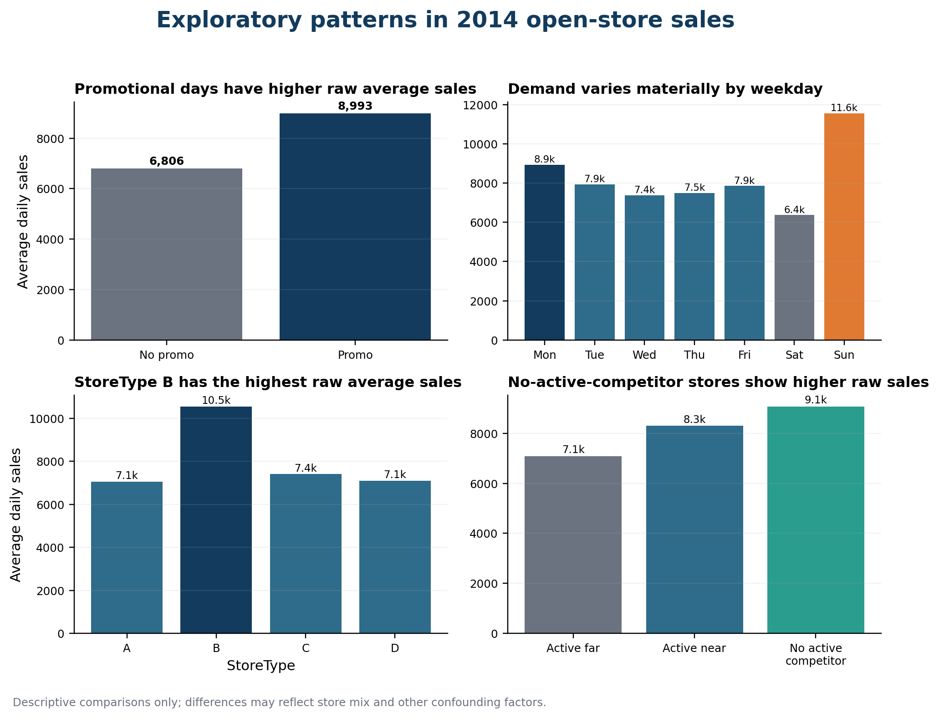
Figure 1. Raw sales patterns across promotion status, weekday, StoreType, and competition exposure.

Promotions are associated with higher sales: 8,993 on promotional days versus 6,806 otherwise, a raw lift of 32.1%. Demand also follows a clear calendar pattern: Monday is relatively strong, Saturday is weakest, December records the highest monthly average, and Sunday comparisons are selective because only 17 stores were open.
Store characteristics matter descriptively, as StoreType B and Assortment B show the highest raw averages, although these differences may reflect store mix and other unobserved factors. Competition exposure is also associated with different sales levels: stores with no active competitors average approximately 9,075, compared with 8,302 for active-near competitors and 7,094 for active-far competitors. However, nearby competition does not necessarily reduce sales more, since active-near stores outperform active-far stores, possibly because they operate in denser, higher-traffic markets. Competition distance is therefore an incomplete measure because it does not capture competitors’ size, pricing, quality, customer traffic, or local market demand.
Overall, these raw comparisons show association rather than causality, so regression is required to separate the effects of correlated factors such as location, seasonality, operating schedules, and individual store characteristics.

3.3.2 How the Business Predictors Relate to Regular Daily Promotion

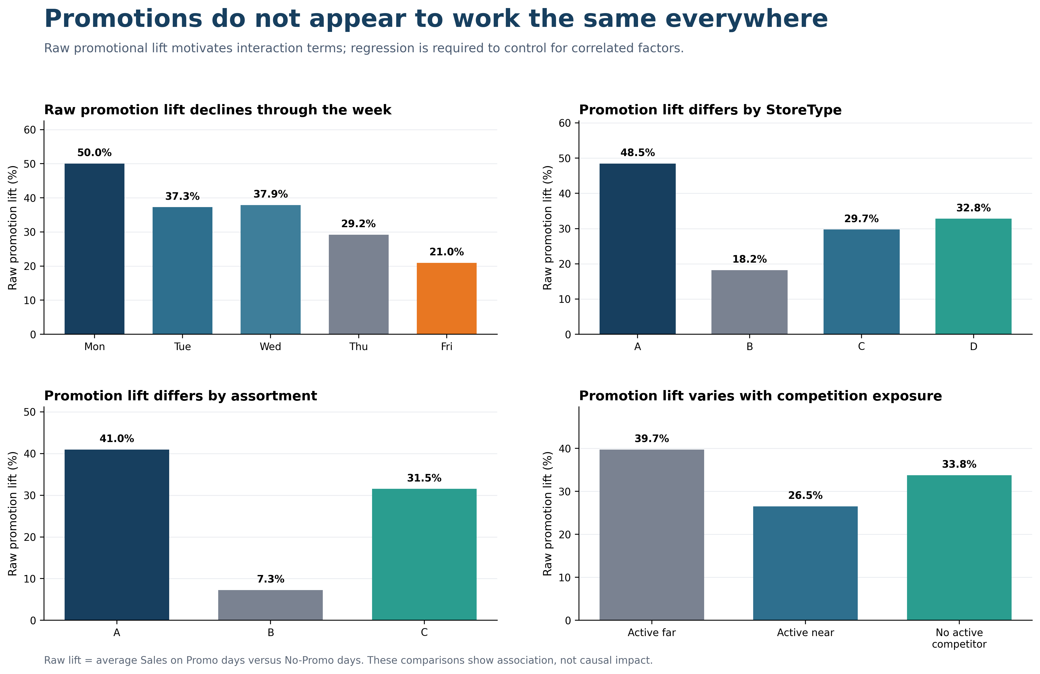
Figure 2. Relationships Among Promotion, Calendar, and Store Characteristics

Promotion effectiveness varies materially across business conditions. Raw promotion lifts declines from 50.0% on Monday to 21.0% on Friday, suggesting that promotional intensity, inventory, and staffing should be adjusted by weekday rather than applied uniformly. Store format also matters: StoreType A records the highest lift at 48.5%, while StoreType B shows only 18.2%, indicating that the same promotion strategy may not suit every store model. Assortment further shapes performance, with Assortment A generating a 41.0% lift, compared with 7.3% for Assortment B and 31.5% for Assortment C. Competitive conditions also appear relevant, as stores with far competitors show a 39.7% lift, compared with 26.5% for near competitors and 33.8% for stores with no active competitor. Overall, promotion planning should be segmented by weekday, StoreType, assortment, and local competition.

3.3.3 Promo2 Participation and Sales
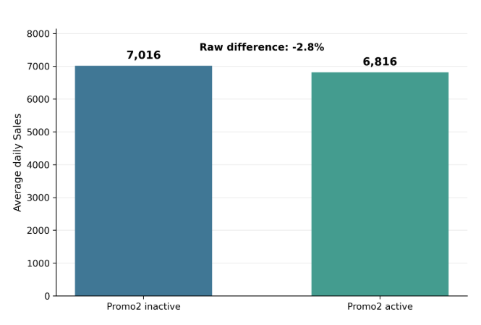
Figure 3. Overall Promo2 Active vs Inactive

Promo2 does not show a broad raw sales uplift. Among participating stores, average sales during active Promo2 months were approximately 2.8% lower than during inactive months. The daily Promo variable shows a strong positive raw association with sales, whereas Promo2 does not demonstrate the same consistent pattern. Month, seasonality, daily Promo activity, holidays, and differences among stores may explain part of the observed Promo2 pattern.

3.4 Predictive Modelling with OLS Regression
OLS models were estimated using LogSales as the target variable, with January–February 2015 reserved as the chronological test period.
Model development proceeded in stages. The initial specification used business predictors without store indicators or interaction terms. Store fixed effects, implemented using C(Store), were then added to control persistent differences among individual stores. Using the store fixed-effects specification as the base model, promotion-related interaction terms were introduced sequentially to evaluate whether promotion effectiveness varied across weekdays, StoreType, assortment, competition exposure, school holidays, and Promo2 conditions.
Candidate models were evaluated using training and test $R^{2}$, RMSE, and MAE. Final model selection was based primarily on test-set performance. (see Appendix A, B)
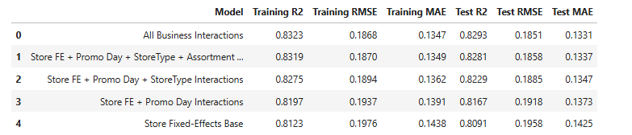

Training and Test Performance of Candidate OLS Models

Adding store fixed effects produced the largest improvement, increasing test $R^{2}$from 0.2776 to 0.8091. This indicates that persistent store-level differences explain most of the variation in sales.
Business interactions provided further improvement. The All-Business Interactions model achieved the highest test $R^{2}$of 0.8293 and the lowest test RMSE and MAE of 0.1851 and 0.1331. It was therefore selected as the final forecasting model.
However, its improvement over the simpler Promo Day, StoreType, and Assortment interaction model was small, with test $R^{2}$increasing by only 0.0012.

Overall, store-specific characteristics drive most of the forecast improvement, while business interactions provide additional value by identifying where promotions are more or less effective.

3.5 Model Assessment and Hypothesis Testing

3.5.1 Heteroskedasticity assessment
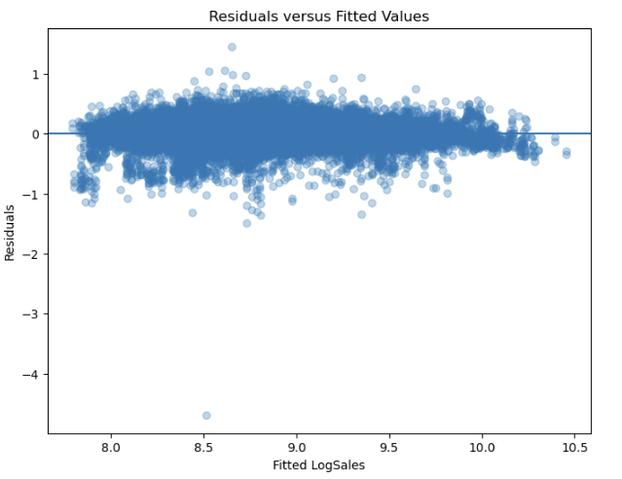
Figure 4. Residuals versus fitted LogSales for the All-Business Interactions model.

Residuals are centered around zero with no strong nonlinear pattern, but their spread narrows as fitted LogSales increases. This indicates heteroskedasticity, while several large negative residuals suggest possible influential observations.

The Breusch–Pagan test confirms this result:
Test | p-value | Decision
LM test | <0.001 | Reject Null Hypothesis Homoscedasticity
F test | <0.001 | Reject Null Hypothesis Homoscedasticity

The residuals are heteroskedastic. Conventional OLS standard errors are therefore not used for hypothesis testing. The model was re-estimated using HC3 heteroskedasticity-robust standard errors (see Appendix D. Residual Diagnostics and HC3 Robust Inference). HC3 does not change the estimated coefficients, fitted values, $R^{2}$, or forecasts. It corrects the standard errors, confidence intervals, p-values interference rest result.

3.5.2 Residual normality
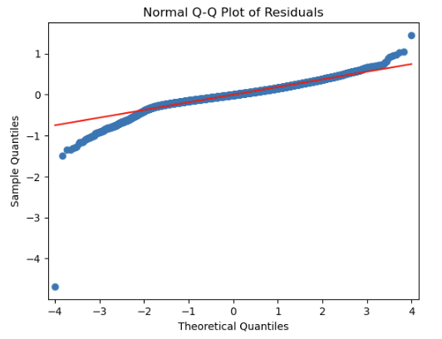
Figure 5. Normal Q–Q plot of residuals for the All-Business Interactions model.

The Q–Q plot shows that the central residuals are reasonably close to normal, but both tails deviate materially from the reference line, with one extreme negative residual. Therefore, the normality assumption is not fully satisfied.
Given the large training sample of 31,249 observations, exact residual normality is not critical for large-sample inference. The more important issue is heteroskedasticity, which is addressed using HC3 heteroskedasticity-robust standard errors. Extreme observations should be reviewed using studentized residuals and Cook’s distance rather than removed automatically.

3.5.3 Outlier and Influential observations

The Cook’s-distance rule identified 1,507 observations above the $\frac{4}{n}$screening threshold (see Appendix E for the detailed Cook’s-distance results and the most influential observations). Because the sample is very large, the cutoff is extremely small—approximately 0.000128—so this count should be treated as a review list rather than evidence that 1,507 records should be removed.
The largest Cook’s distance is only 0.0175, far below the conventional benchmark of 1. Therefore, no single observation has overwhelming influence on the model. However, several records contain extreme studentized residuals. The most unusual case is Store 652 on November 22, 2014, with Sales of only 46, a studentized residual of approximately −25.1, and the highest Cook’s distance.
These observations should not be deleted automatically. They may represent data errors, unusual closures, system problems, stock shortages, or valid low-demand business events. The appropriate response is to validate the underlying records and to conduct a sensitivity analysis by re-estimating the model without observations that are both extreme residual outliers and above the Cook’s-distance cutoff.

3.5.4 Business Hypothesis Testing
All hypotheses (see Appendix C) were tested using the All-Business Interactions model. Statistical inference was based on HC3 heteroskedasticity-robust standard errors, and groups of related coefficients were assessed using joint Wald tests at the 5% significance level. Rejection of $H_{0}$indicates that the tested factor provides statistically significant information after controlling for the other variables in the model.
Because the dependent variable is $\text{LogSales}$, coefficients are converted into percentage effects such as:
$$\%Δ\text{Sales}=100\left(e^{β}-1\right)$$
For interaction effects, the relevant main-effects and interaction coefficients are combined before applying the transformation:
$$\%Δ\text{Sales}=100\left(e^{β_{\text{Promo}}+β_{\text{Interaction}}}-1\right)$$
- Which factors matter most about store sales?

Adding C(Store) increased test $R^{2}$by 0.5315, substantially more than any other modelling change. The joint Wald test produced $p<0.001$, confirming that individual-store effects are jointly significant at 5% significant level.
Store identity is not an actionable business driver. Instead, it absorbs persistent but unobserved store-level characteristics, including location quality, neighbourhood traffic, store size and operating capacity, local customer demographics and income, customer loyalty, product availability, management quality, and other stable conditions.
Management should therefore retain store-specific forecasting while collecting richer customer, location, traffic, capacity, inventory, and management-quality data to explain the variation currently captured by the store indicators.

- Do regular promotions still matter after controlling other factors?
$$H_{0}:\text{Promo and all Promo interaction coefficients are jointly zero} \\ H_{1}:\text{At least one promotion-related coefficie}\text{nt is non-zero}$$
The joint Wald test rejected null hypothesis at the 5% significance level (p<0.001), confirming that regular daily promotion and its interactions are jointly significant. The result shows that promotion and its interaction effects jointly add explanatory value to the model; it does not imply that every individual promotion coefficient is significant or that the promotion uplift is identical across all store-day conditions.

- Does promotion effectiveness vary by weekday?
$$H_{0}:\text{Weekday and Promo × weekday coefficients are jointly zero} \\ H_{1}:\text{At least one weekday-related coefficient is non-zero}$$
Monday is the reference weekday. Under the model’s other reference conditions, the estimated Monday promotion effect is 0.5805, corresponding to an estimated Sales uplift of 78.7%.
$$100\left(e^{0.5805}-1\right)=78.7\%$$

Weekday | Combined log effect | Estimated promotion uplift
Monday | $$0.5805$$ | 78.7%
Tuesday | $$0.5805-0.1000$$ | 61.7%
Wednesday | $$0.5805-0.1024$$ | 61.3%
Thursday | $$0.5805-0.1902$$ | 47.7%
Friday | $$0.5805-0.2624$$ | 37.4%

Conditional promotion effects by weekdays
The Tuesday-to-Friday promotion effects are obtained by adding the relevant Promo × weekday interaction coefficient to 0.5805 and then converting the combined log effect into a percentage.
The joint Wald test rejects the null hypothesis that all Promo × weekday interaction coefficients are zero ($p<0.001$). Therefore, promotion effectiveness varies significantly across weekdays.
The estimated promotion uplift declines steadily throughout the week, from approximately 78.7% on Monday to 37.4% on Friday. This suggests that promotions generate the strongest incremental Sales response earlier in the week.
Management should therefore allocate more promotional inventory and staffing support to Monday through Wednesday and should not assume that the same promotion uplift applies throughout the week. Because no regular promotional observations were available on Saturday or Sunday, no comparable weekend promotion effect can be estimated.

- Do store characteristics affect promotion effectiveness?
StoreType
$$H_{0}:β_{\text{Promo}×\text{StoreType B}}=β_{\text{Promo}×\text{StoreType C}}=β_{\text{Promo}×\text{StoreType D}}=0 \\ H_{1}:\text{At least one Promo × StoreType coefficient is non-zero}$$
Assortment
$$H_{0}:β_{\text{Promo}×\text{Assortment B}}=β_{\text{Promo}×\text{Assortment C}}=0 \\ H_{1}:\text{At least one Promo × Assortment coefficient is non-zero}$$

Store characteristic | Estimated promotion uplift
StoreType A | 78.7%
StoreType B | 60.7%
StoreType C | 56.2%
StoreType D | 61.2%
Assortment A | 78.7%
Assortment B | 42.5%
Assortment C | 62.9%

Conditional promotion effects
Both null hypotheses are rejected at the 5% significance level. Promotion effectiveness differs significantly across StoreTypes ($p<0.001$) and assortment levels ($p<0.001$). Promotion effectiveness differs significantly across StoreTypes and assortment levels. StoreType A has the strongest estimated response among store formats, while Assortment B has the weakest overall response. Rossmann should segment promotion planning by both store format and product mix, with review of promotion design and execution in Assortment B stores.
Because C(Store) absorbs time-invariant StoreType and assortment main effects, these tests evaluate differences in promotion response, not baseline Sales differences.

- Do calendar patterns matter?

Month effects
$$H_{0}:β_{\text{Month 2}}=β_{\text{Month 3}}=⋯=β_{\text{Month 12}}=0 \\ H_{1}:\text{At least one month coefficient is non-zero}$$
State-holiday effects
$$H_{0}:β_{\text{StateHoliday a}}=β_{\text{StateHoliday b}}=β_{\text{StateHoliday c}}=0 \\ H_{1}:\text{At least one state-holiday coefficient is non-zero}$$
School-holiday effects
$$H_{0}:β_{\text{SchoolHoliday}}=β_{\text{Promo}×\text{SchoolHoliday}}=0 \\ H_{1}:\text{At least one school-holiday-related coefficient is non-zero}$$
Calendar patterns (month effects, state-holiday effects, and school-holiday effects) are jointly significant. Month effects are significant (p<0.001), with December Sales estimated to be 28.7% higher than January, holding other factors constant. StateHoliday effects are also jointly significant (p<0.001): public holidays are associated with approximately 24.6% higher Sales, while Easter shows a borderline 14.7% increase and Christmas an insignificant 11.3% decrease. SchoolHoliday and its interaction with Promo are jointly significant (p=0.0039), although the economic effect is modest. Month and holiday variables should therefore remain in the forecasting model, with additional inventory and staffing planned for December and holiday forecasts adjusted for selective store openings.

- Does competition exposure affect store performance?
$$H_{0}:\text{Competition effects and Promo × c}\text{ompetition effects are jointly zero} \\ H_{1}:\text{At least one competition-related coefficient is non-zero}$$
The joint Wald test fails to reject $H_{0}$($p=0.400$), indicating that competition exposure and its interactions with regular promotion are not jointly significant after controlling for individual-store effects and other operating conditions. The estimated Promo × active-near and Promo × active-far differences are also individually insignificant. Competition distance therefore does not provide reliable incremental explanatory power in the final model. Management should not conclude that competition is commercially irrelevant; rather, distance alone is an incomplete measure. Richer local-market data on competitor size, pricing, quality, customer traffic, and market density are needed before competition exposure is used for forecasting or resource allocation.

- Does Promo2 affect Sales?
$$H_{0}:\text{Promo2 effects and Promo × Promo2 interactions are jointly zero} \\ H_{1}:\text{At least one Promo2-related coefficient is non-zero}$$
The joint Wald test rejects $H_{0}$($p<0.001$), showing that Promo2 and the Promo × Promo2 interaction terms are jointly significant. This means Promo2 provides useful information for forecasting and changes how strongly stores respond to regular daily promotions. Plan A and Plan C are associated with a stronger regular-promotion response, while Plan B is associated with a weaker response.
This result does not conflict with the descriptive analysis in the Data Exploration section, where average Sales during active Promo2 periods were approximately 2.8% lower than during inactive periods. That raw comparison simply compared group averages and did not control store identity, month, regular Promo, holidays, or other related factors. After these factors are controlled in the regression model, Promo2 remains jointly significant. Management should therefore retain Promo2 in forecasting but evaluate its performance separately by plan and store segment.

Executive question | Factor tested | p-value | Conclusion (alpha 5%) | Management implication
Which factors matter most about store sales? | Individual-store effects | <0.001 | Jointly significant; largest increase in test $R^{2}$ | Use store-specific forecasts and collect richer customers, location, traffic, capacity, and management data.
Do promotions still matter after considering other factors? | Promo and all Promo interactions | <0.001 | Jointly significant | Use segmented promotion planning.
Do store characteristics affect promotion performance? | Promo × StoreType | <0.001 | Jointly significant | Tailor promotions by store format.
 | Promo × Assortment | <0.001 | Jointly significant | Align promotions with product mix.
How do holidays affect sales? | StateHoliday | <0.001 | Jointly significant | Include holidays in forecasts and staffing.
 | SchoolHoliday and interaction | 0.0039 | Jointly significant | Retain school-calendar effects; impact is modest.
How does competition affect performance? | Competition and interactions | 0.400 | Not jointly significant | Do not rely on distance alone; obtain richer local market data.
Does Promo2 matter? | Promo2 and interactions | <0.001 | Jointly significant | Retain for forecasting; assess ROI by plan and segment.

Summary of Business Hypothesis Tests

3.6 Prediction Performance
Prediction performance was evaluated using the 2014 training sample and the January–February 2015 holdout sample. Because the regression dependent variable is LogSales, R2, RMSE, and MAE were calculated by comparing actual and predicted LogSales.

3.6.1 Point Prediction Accuracy

Sample | (R^2) | RMSE | MAE
Training | 0.8323 | 0.1868 | 0.1347
Test | 0.8293 | 0.1851 | 0.1331

The model explains approximately 83.2% of the variation in training LogSales and 82.9% of the variation in test LogSales. The similar training and test results indicate that the model maintains its predictive performance on unseen data and does not show a material sign of overfitting.
The test RMSE of 0.1851 measures the typical prediction error on the log scale while giving greater weight to large errors. The test MAE of 0.1331 represents the average absolute difference between actual and predicted LogSales.

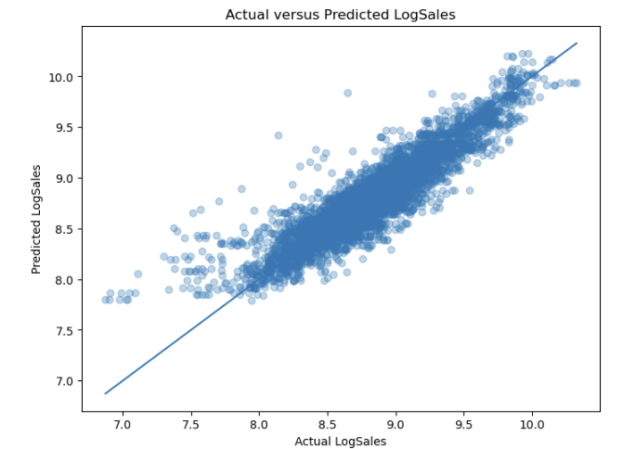

Figure 6. Actual versus Predicted LogSales

Figure 6 compares actual and predicted LogSales in the test sample. The 45-degree reference line represents perfect prediction where $\text{Predicted LogSales}=\text{Actual LogSales}.$ We can see that most observations are concentrated near this line, indicating close agreement between actual and predicted values. Points above the line represent overprediction, while points below the line represent underprediction.
The model performs well across the main range of daily sales. Greater dispersion at the lower and upper ends indicates that prediction errors are larger for some unusually low- or high-sales observations. The model may also slightly underpredict some of the highest-sales days.
The model provides stable forecasts for typical store days. Management can use the point forecast as the central daily sales estimate for inventory, staffing, and promotional planning. However, unusual sales days remain less predictable and should be assessed using prediction intervals and business judgment.

3.6.2 Prediction Intervals
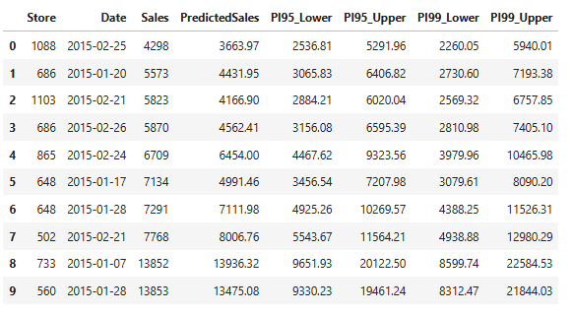
95% and 99% prediction intervals

Prediction interval table above presents 10 randomly selected observations from the empirical January–February 2015 test sample. For each observation, the table reports actual Sales, predicted Sales, and the 95% and 99% prediction intervals.
The prediction intervals were initially estimated on the LogSales scale and then exponentiated to return them to the original Sales scale. Across the complete test sample, 95.30% of actual Sales observations fell within the 95% prediction intervals, closely matching the intended 95% coverage rate. This indicates that the 95% intervals are well calibrated for the holdout period.
For the 99% prediction intervals, 97.74% of actual Sales observations were captured. Although the 99% intervals provided greater coverage than the 95% intervals, their observed coverage was below the intended 99% level. This suggests that the model may underestimate uncertainty for some unusually high- or low-sales observations.
From a management perspective, the point forecast represents the model’s central estimate of daily Sales, while the prediction interval provides a more realistic planning range. Managers can use the lower and upper limits when making inventory, staffing, and promotion decisions. The intervals should be treated as decision-support ranges rather than guaranteed minimum and maximum sales levels.

Conclusion and Model Limitations
The model should be used as a decision-support tool rather than an automatic decision rule. Its forecasts are most appropriate for known stores operating under conditions similar to those observed in the historical sample and should be combined with prediction intervals, operational knowledge, and management judgment.
Several limitations should be considered. First, the analysis covers only 100 selected stores, so the findings may not fully represent the complete Rossmann network. Store fixed effects also improve predictions for stores included in the historical data but limit the model’s ability to forecast newly opened or previously unseen stores.
Second, the results represent statistical associations rather than causal effects. In particular, the estimated promotion effects should not be interpreted as Sales caused entirely by promotion because promotional activity may be scheduled when stronger demand is already expected.
Third, important business variables are unavailable, including customer behavior, pricing and discount depth, promotion cost, inventory availability, stockouts, product mix, weather, competitor quality, and local market traffic. Competition distance alone is therefore insufficient to represent local competitive conditions.
Fourth, the residual analysis identified heteroskedasticity and deviations from normality. HC3 robust standard errors improve the reliability of statistical inference, but unusual high- and low-sales days remain less predictable. The model also applies only to open stores with positive Sales, and weekend promotion effects could not be estimated because regular weekend promotions were not observed.
The project used course covered OLS regression and inference methods which provide strong business interpretability. Its coefficients, interaction effects, and hypothesis tests allow management to understand how expected Sales change across business conditions. However, OLS may not fully capture nonlinear relationships, threshold effects, and complex interactions.
Future work should compare the current model with XGBoost, random forests, regularized regression, generalized additive models, and mixed-effects models using the same chronological holdout period and evaluation metrics. A more complex model should be adopted only if it produces meaningful out-of-sample improvement without sacrificing operational transparency. Future development should also incorporate customer, pricing, inventory, promotion-cost, and local-market data to improve both forecasting accuracy and business interpretation.

Technical Appendix

Appendix A. Model Specifications
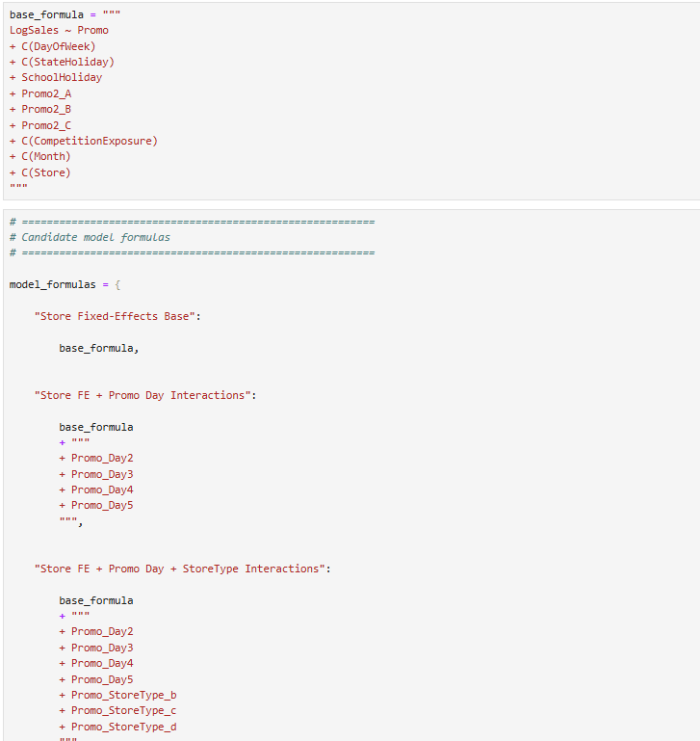
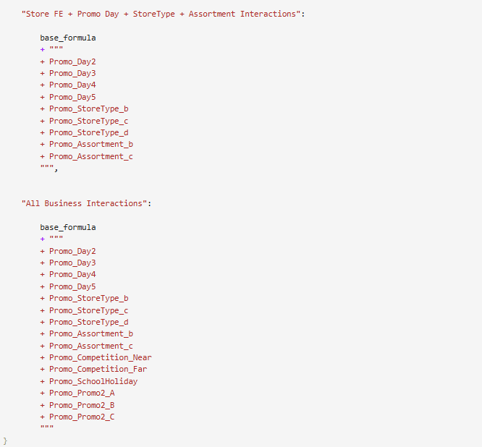

Appendix B. Candidate-Model Comparison
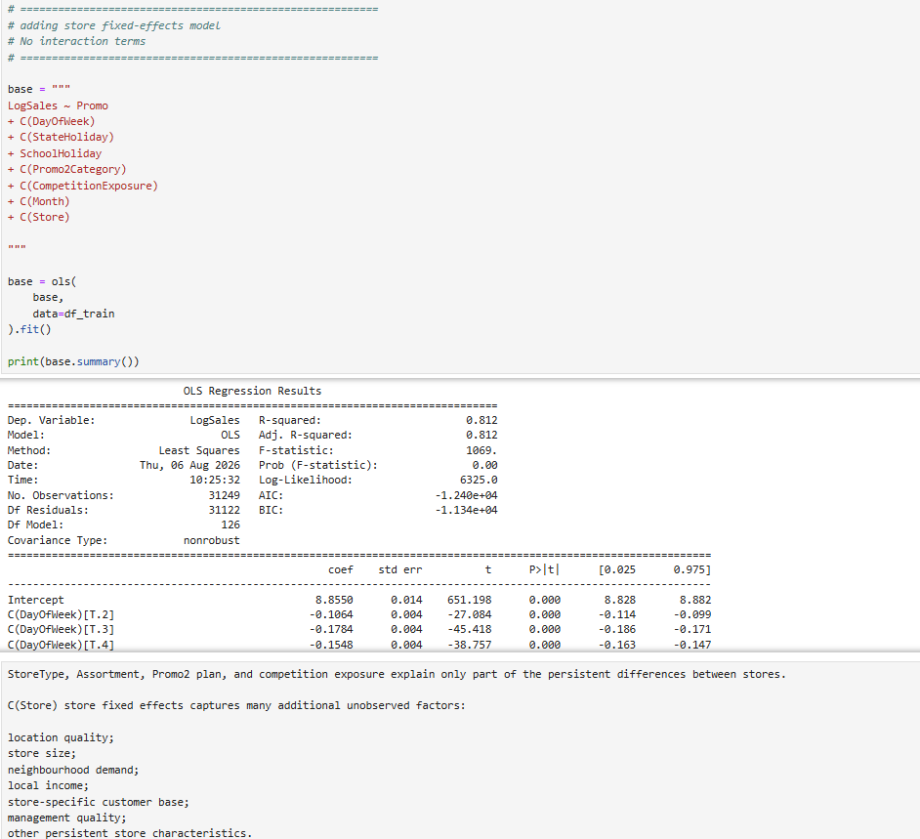

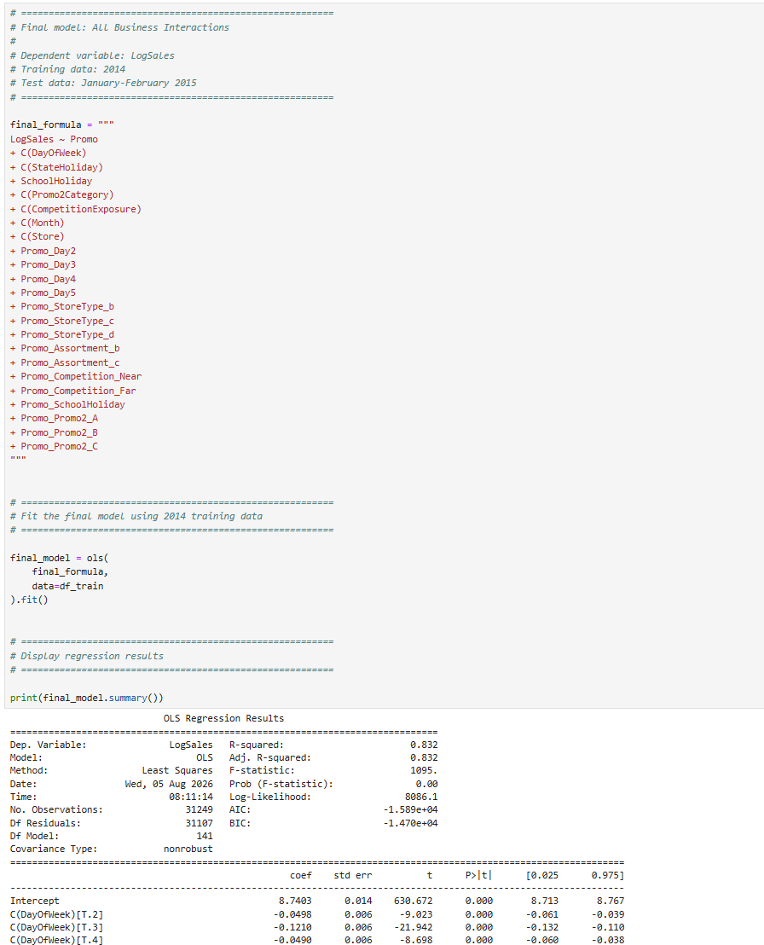
…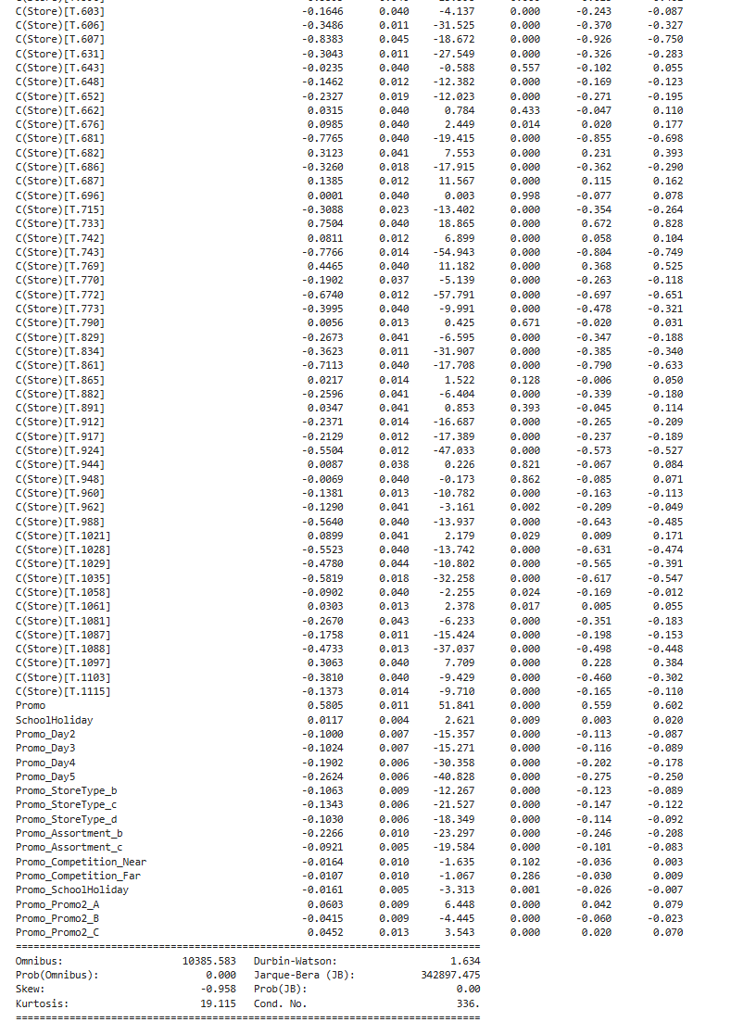

Appendix C. Hypotheses and Wald-Test Results
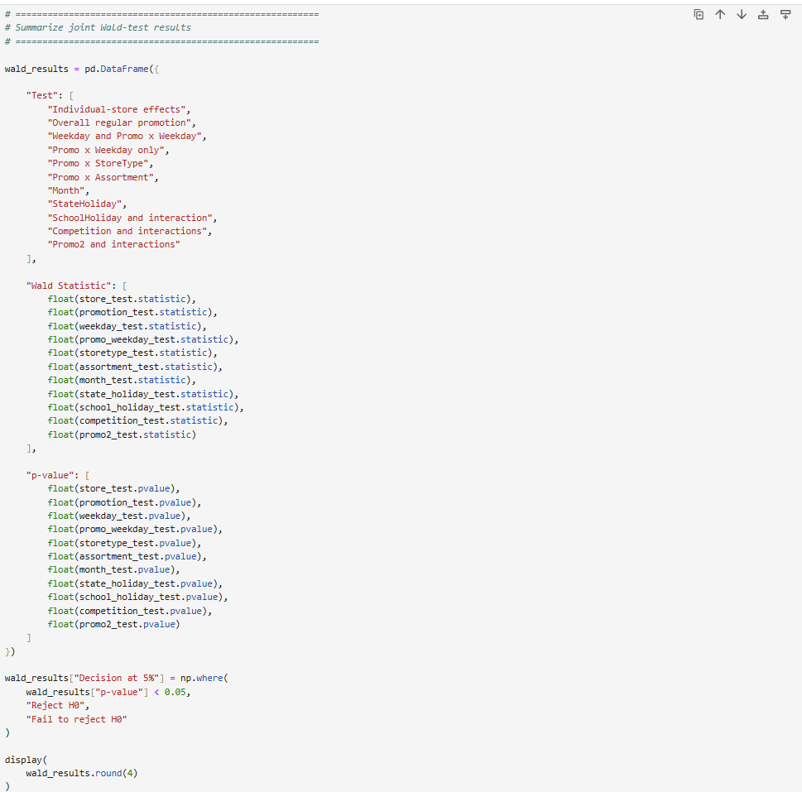
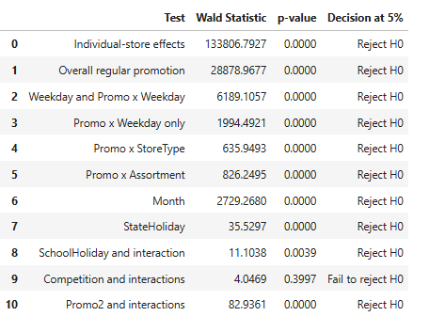

Appendix D. Residual Diagnostics and HC3 Robust Inference
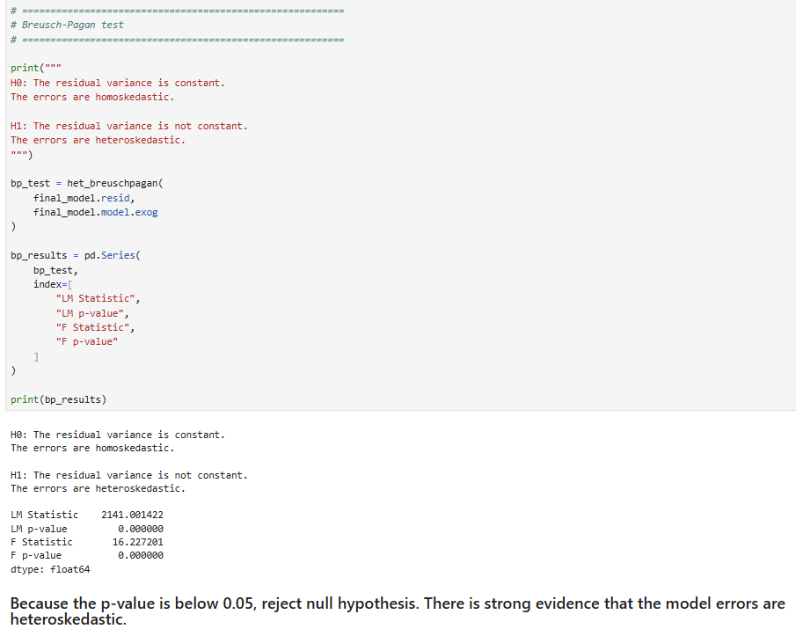
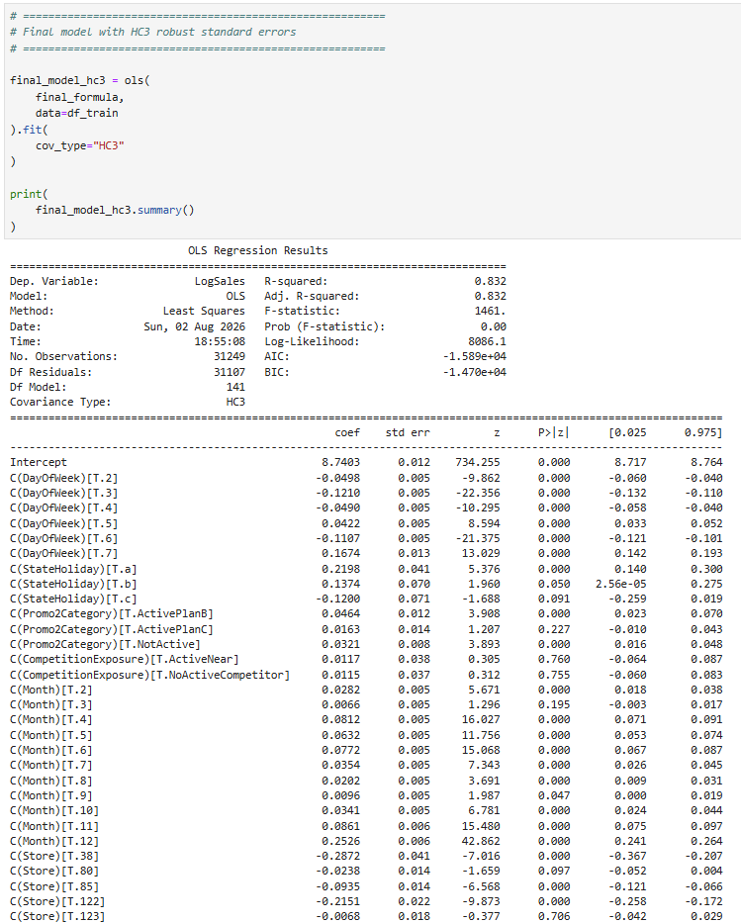

Appendix E. Outliers, Leverage, and Cook's Distance

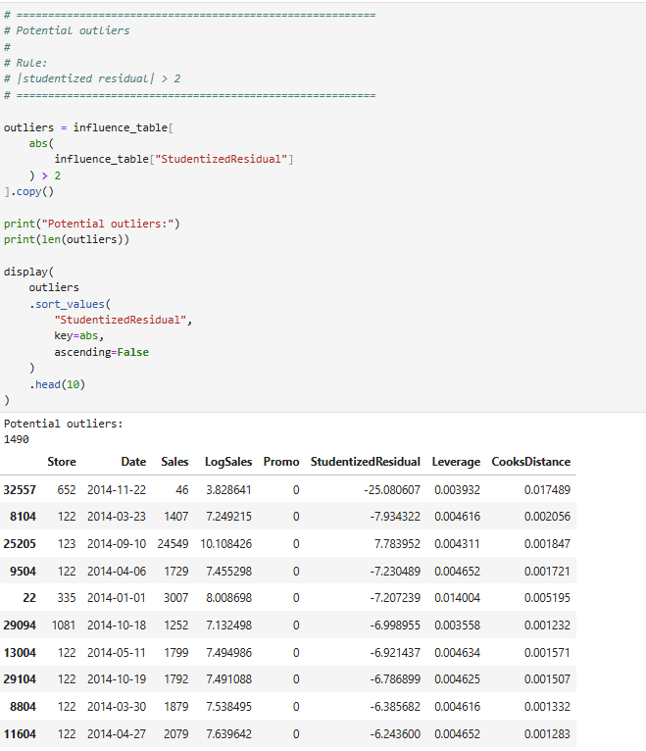
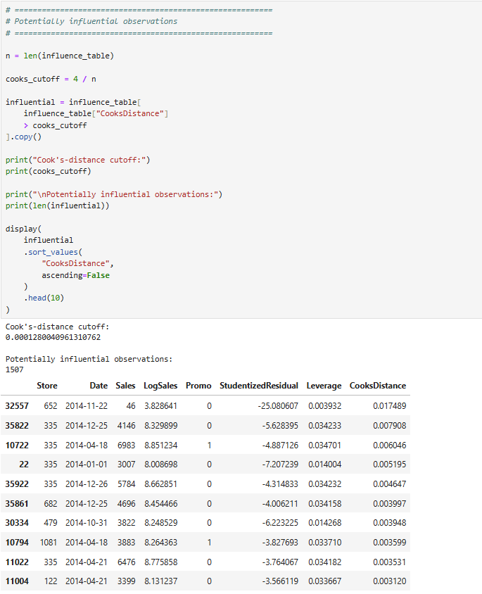

Appendix F. Prediction Validation and CI/PI
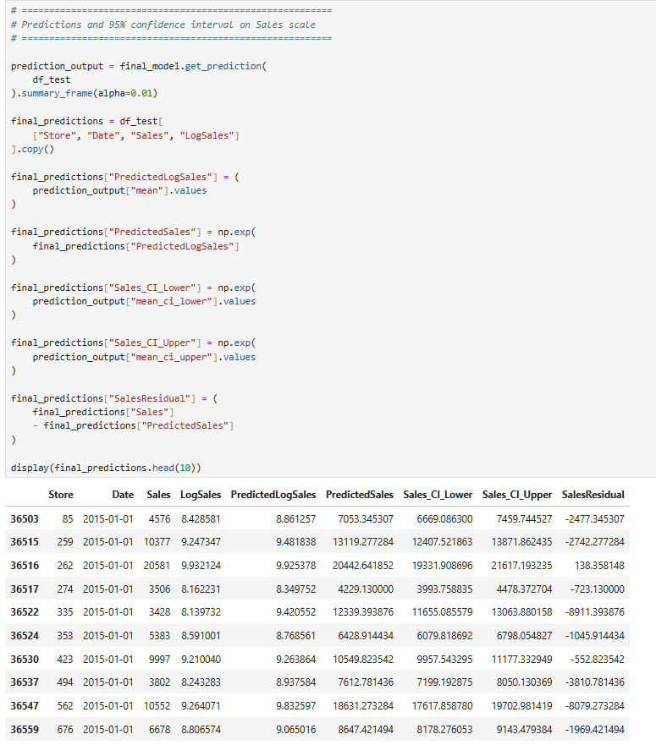
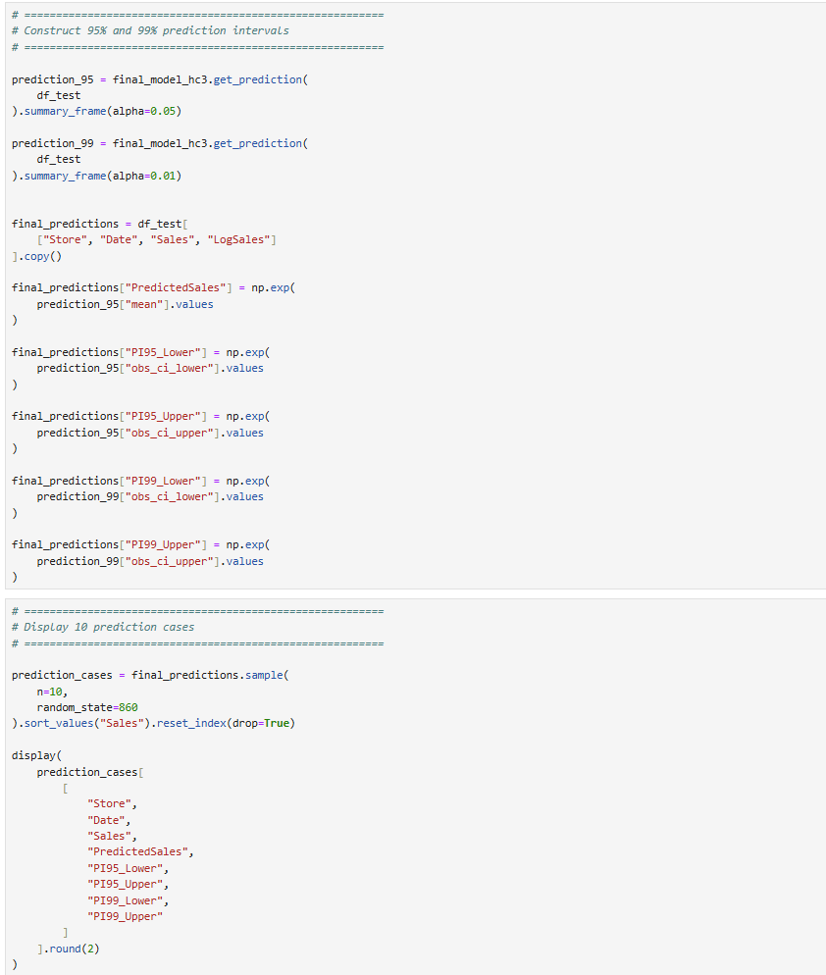
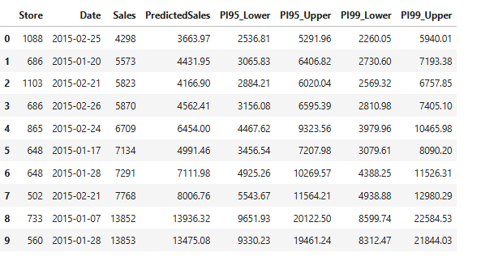
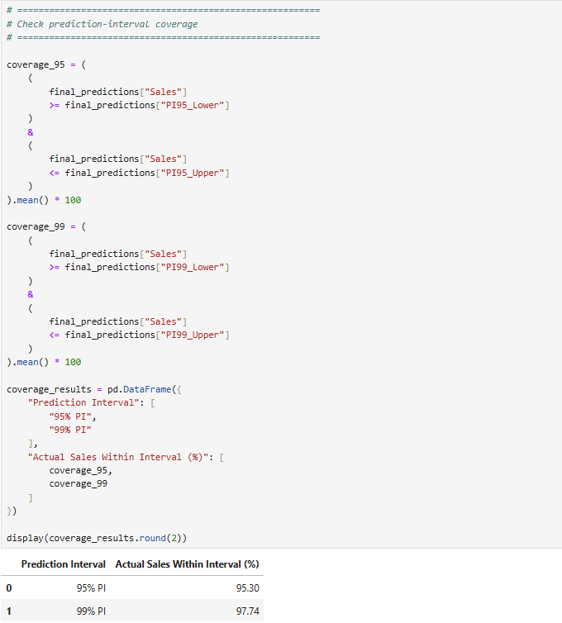

Appendix J. Notebook and Code Reference
See separated Jupyter notebook

